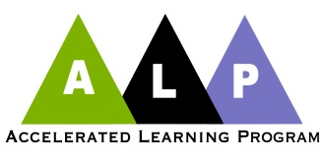
Butler’s Accelerated Learning Program in English
Butler Community College’s Accelerated Learning Program (ALP) is a co-requisite approach to developmental writing originally developed at the Community College of Baltimore County (CCBC). Nationally, ALP is considered to be one of the most effective models in developmental English. Over 200 community colleges, including Butler, are now using the program. Butler began teaching ALP classes in spring 2013.

Students who pass an ALP class earn six credit hours – three for the class in which they place class and three for a higher level class – and move through the developmental sequence faster than students in non-ALP classes.

SUMMARY of ALP at Butler
ALP students simultaneously enroll in the writing class in which they place and the next class in the sequence.
ALP classes are scheduled back-to-back and are taught by the same teacher.
ALP students should anticipate that the work load of these courses will be equivalent to six credits.
ALP students may drop the higher course only or both courses, but not the lower course only.
ALP students must pass both levels to earn a passing grade in the higher course.
ALP course grades are recorded separately on the transcript.
Financial Aid regulations apply.
“I understand and agree to the parameters of ALP as explained above.”
____________________________________ _________________
(Print name) (Date)
______________________________________ (Signature)

